Case Study: Navigation
MS | Math | Case Study | 2026 | Adventure

Overview
"Please stop!" Filberto yells nothing — it's the man on the sidewalk who yells, waving both arms at the cab like he's flagging down a plane. Filberto is only three blocks from home, radio off, window down, when he sees him. He pulls the taxi to the curb anyway.
"Please, can you take us to the hospital?" The man's voice cracks on hospital. Behind him a woman is doubled over against the hotel awning, one hand flat on her stomach, breathing in short counted bursts. "My wife is in labor. The baby could come any minute."
Filberto has driven this city for twenty years. He has carried runaway grooms, a man with a gunshot graze, a boy who'd never seen snow. He has never once said no to this. "Jes, jes, I cansa tak yu," he says, already reaching back to pop the door.
"Thank you — thank you." Thomas half-lifts, half-guides Rachel into the back seat and climbs in after her, pulling her hand into both of his. "It's going to be okay. We're going to make it, honey."
Filberto checks his mirrors, pulls out onto the empty Sunday street, and glances at the woman in the back seat — pale, sweating, counting under her breath — then at the road ahead, empty all the way to the corner. His foot hovers over the pedal.
He is already doing exactly the speed limit.

Background
Rachel and Thomas are in Modus City for a conference and have never been in the city before; in the rush for the taxi, both left their phones in the hotel room. Rachel is nine months pregnant with the couple's second child. Their first arrived just 1.5 hours after labor began — Rachel's labor started 20 minutes ago. She is in pain and frightened, but there is no injury and no complication beyond needing to reach the hospital before the baby does. Nobody in that back seat wants this delivery happening in Filberto's taxi.
Filberto has driven a cab in Modus City for over twenty years and knows its streets by feel. His last fare robbed him of his phone and cash before he picked up Rachel and Thomas — no GPS, only the route in his head and what twenty years behind the wheel has taught him about how a car actually moves through this city (SEE APPENDIX B):
- Stopping fully at a stop sign costs an extra 4 seconds before the car can start moving again.
- From a full stop, turning left costs 2 more seconds; turning right costs 1 more second; going straight through costs 1 more second.
- Cars drive on the right side of the road in Modus City, same as the USA.
- Every divided highway in Modus City has no stop signs and is posted at 45 mph.
- Every other road has a stop sign at every intersection and is posted at 25 mph.
It is early on a Sunday morning, so the streets are essentially empty — no traffic to slow him down and, just as importantly, no traffic to hide behind.
Modus City enforces its traffic laws on taxi drivers with cameras, not officers. A single confirmed violation — a missed stop sign, or clocking over the posted limit — is enough for the city to permanently pull a driver's taxi license and issue a fine north of $10,000, far harsher than an ordinary speeding ticket (SEE APPENDIX E). For Filberto, the license is not a formality. It is the only license he has ever needed to earn a living.
Filberto's known route from the hotel to the hospital runs through four segments — two ordinary Modus City streets, one stretch of the city's one divided highway, and one more ordinary street on the hospital side (SEE APPENDIX A, APPENDIX C). Every segment's distance, road type, speed limit, and stop-sign count are fixed before Filberto pulls away from the curb — what is not fixed is how fast he drives them.
Filberto has two ways to run this route. Call the first The Clean Run: hold the posted limit on every segment, camera-safe start to finish. Call the second The Hot Run: pick some amount over the posted limit and hold it the whole way, trading a real but limited amount of time for a real and severe penalty if a single camera catches him.

Dilemma
You are Filberto. Do you: A.) Stay at or under the speed limit for the entire drive OR B.) Speed to get Rachel to the hospital faster, risking Filberto's license and a $10,000+ fine

Challenges
1.) Research and find an online resource that answers one of the "how to…" questions from the case study launch. Post a link to the resource as your submission.
2.) Post 250 or more "excellent" words pitching a firm stance to your audience on which you would choose and why. Your pitch must include: a.) Use of the "how to…" resource you researched in Challenge 1. b.) At least one original visual display of the data.
3.) Your pitch must include (the "how to…" questions referenced above are listed in APPENDIX F): D1. A labeled route drawing from the Hotel to the Hospital, tracing the four segments in Appendix C over the map in Appendix A, with each segment's road name, distance, and speed-limit classification marked. D2. A segment-by-segment drive-time table for The Clean Run (Option A): for each of the four segments, distance ÷ posted speed limit converted to a time, plus every stop-sign delay, ending in one grand total elapsed time in minutes and seconds. D3. A second segment-by-segment drive-time table for The Hot Run (Option B), stating exactly how many mph over the posted limit you chose to drive on every segment, ending in its own grand total elapsed time — and the time saved versus Option A, in minutes and seconds and as a percent. D4. A total-risk calculation: using Appendix D and Appendix E's sourced figures, compute the total dollar exposure of Option B if a single camera catches Filberto (the fine plus the cost of losing his license), then express that exposure as a rate — dollars of risk per minute actually saved.
4.) An appendix showing evidence of your original thinking, work, calculations and processes you used to complete the challenges (pictures, screenshots, notes, etc.). Your work in the appendix does not count toward your word count.
5.) Participate twice or more in the Case Study discussion. *If you are absent the day of a discussion post 500 "excellent" words on the questions above.

Appendix A — Map of Modus City
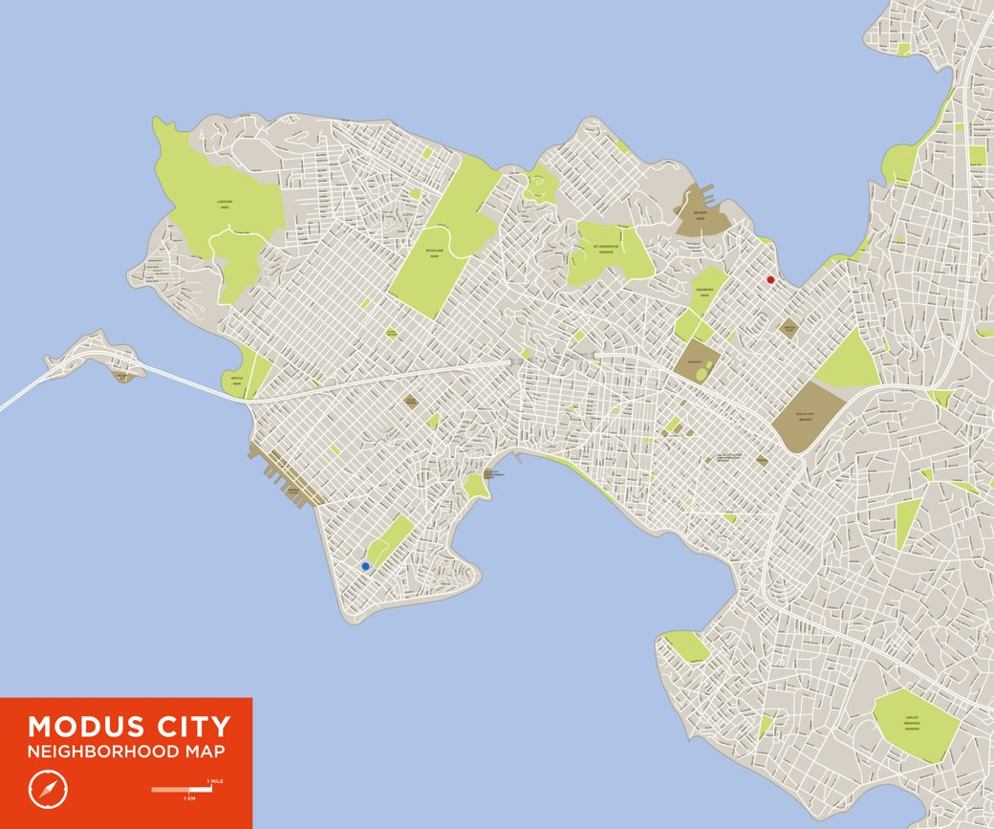
Portfolio13_Modus03.jpg — Modus City neighborhood map. Red dot = hotel. Blue dot = hospital. Scale bar (lower left) = 1 mile / 1 km.
The full neighborhood map Filberto is navigating from memory (SEE Portfolio13_Modus03.jpg, reproduced in the published packet). Red dot = the hotel. Blue dot = the hospital. The scale bar in the lower left reads 1 mile / 1 km — use it to check any distance you measure by eye against Appendix C's given figures.

Appendix B — Filberto's Speed & Stop-Sign Timing Reference
Rule | Cost
Full stop at a stop sign | +4 seconds
Left turn from a stop | +2 seconds (on top of the stop)
Right turn from a stop | +1 second (on top of the stop)
Straight through from a stop | +1 second (on top of the stop)
Divided highway | no stop signs; posted 45 mph
Every other road | stop sign at every intersection; posted 25 mph

Worked example: one stop sign followed by a left turn costs 4 + 2 = 6 seconds total before the car is back up to speed.

Appendix C — Trip Segment Log
Filberto's known route, Hotel to Hospital, broken into its four segments.
Segment | Street | Road type | Distance (mi) | Posted limit (mph) | Stop signs | Turns at those stops
1 | Cannery Row | Ordinary street | 0.6 | 25 | 2 | 1 left, 1 right
2 | Fairview Ave | Ordinary street | 0.8 | 25 | 4 | 1 left, 2 right, 1 straight
3 | Route 9 | Divided highway | 1.5 | 45 | 0 | —
4 | Harbor St | Ordinary street | 0.5 | 25 | 2 | 1 left, 1 right

Total route distance: 3.4 miles.

Appendix D — Modeling Assumptions
These figures are not sourced. They are stated scenario assumptions chosen by the case author. A Hero may challenge them in discussion — that is a legitimate move.
# | Assumption | Value used | Basis | Sensitivity
MA1 | How many years of income a "permanent" license loss actually costs, for the purpose of D4's dollar total | 1 year | The case states the penalty is a permanent license loss, but never states how many years of income that is worth counting for a single dollar figure. One year is used as a conservative floor, not an estimate of Filberto's full remaining career. | A longer assumed loss makes Option B's total risk larger; a shorter one makes it smaller. Either way, D4's dollar-per-minute figure stays a large multiple of a single ride's fare — the sensitivity is in the size of the multiple, not in which option that fact favors.

Appendix E — Sources
# | Claim | Value | Source | Date | Confidence
S1 | U.S. median annual wage for a taxi driver — used in Appendix D, MA1, to price one year of Filberto's lost income if his license is revoked | $42,100/year | O*NET OnLine — Taxi Drivers (53-3054.00), reporting 2025 BLS wage data (link) | 2025 | HIGH
S2 | Typical U.S. speeding-ticket cost for an ordinary civilian driver, for comparison only — establishes that Modus City's stated $10,000+ camera penalty for a taxi driver is far more severe than an everyday ticket, not an everyday-scale consequence | $150–$300 (10 mph over, highway, including court fees) | SpeedingCost.com, national average calculator (link) | Updated 2026-06 | MEDIUM

S2 is context, not a load-bearing figure — it does not enter any calculation in Appendix C or D. It establishes that this case's $10,000+ fine is a real kind of consequence (real jurisdictions do fine speeding), scaled up to reflect Modus City's much stricter camera enforcement of professional drivers specifically.

Appendix F — "How To…" Math Questions To Research
Vocabulary terms
- Distance
- Time
- Ratio
- Proportion
- Unit
- Addition
- Subtraction
- Multiplication
- Division
- Percent
- Bar Graph
- Data
"How to…" questions
- How to find a missing amount in a proportion
- How to convert an amount from one unit to another unit
- How to convert between units of time
- How to add and subtract time
- How to find elapsed time
- How to add multi-digit numbers
- How to subtract multi-digit numbers
- How to multiply any two numbers
- How to divide a multi-digit number by a 2-digit number
- How to find the percent of a number
- How to compare two or more values

